using namespace std; **be careful of double vs int**  #include <iostream> for cin and cout

#include <cmath>

#include <string> for anything with a string, size, length, at append

str.assign(string,inclusive start index, how many chars)

str.insert(5, " are "); // Inserts " are " at 5th index of str

str.substr(index, length) returns substring starting at index w length char

str.erase (position of start, length);

str.find(item, indx) starts at index indx.

str.replace(from indx, indxnum (non incl), subStr)

str.size()

#include <cctype>

isdigit(), isupper(), islower(), isspace(), isalpha(), toupper(),tolower()

**if** (isalpha(ch)) //RIGHT && **if** (isalpha(ch) == **true**) // WRONG!!!!

cout.setf(ios::fixed); // double with fixed dp

cout.precision(2);

cin.ignore(100, '\n'); // ignore 100 characters or a new line whichever comes first. After after int before getline

//to check for equality with two floats

**double** x, y;

fabs(x - y) < 0.0001; //fabs is to take absolute value

**switch**(expression) { cout <<; cin>>;

**case** x: //x can only be an int

// code block

**break**;

**default**:

// code block}

The / operator performs floating-point division if at least one operand is a floating-point type.

do{

…} while(expression)

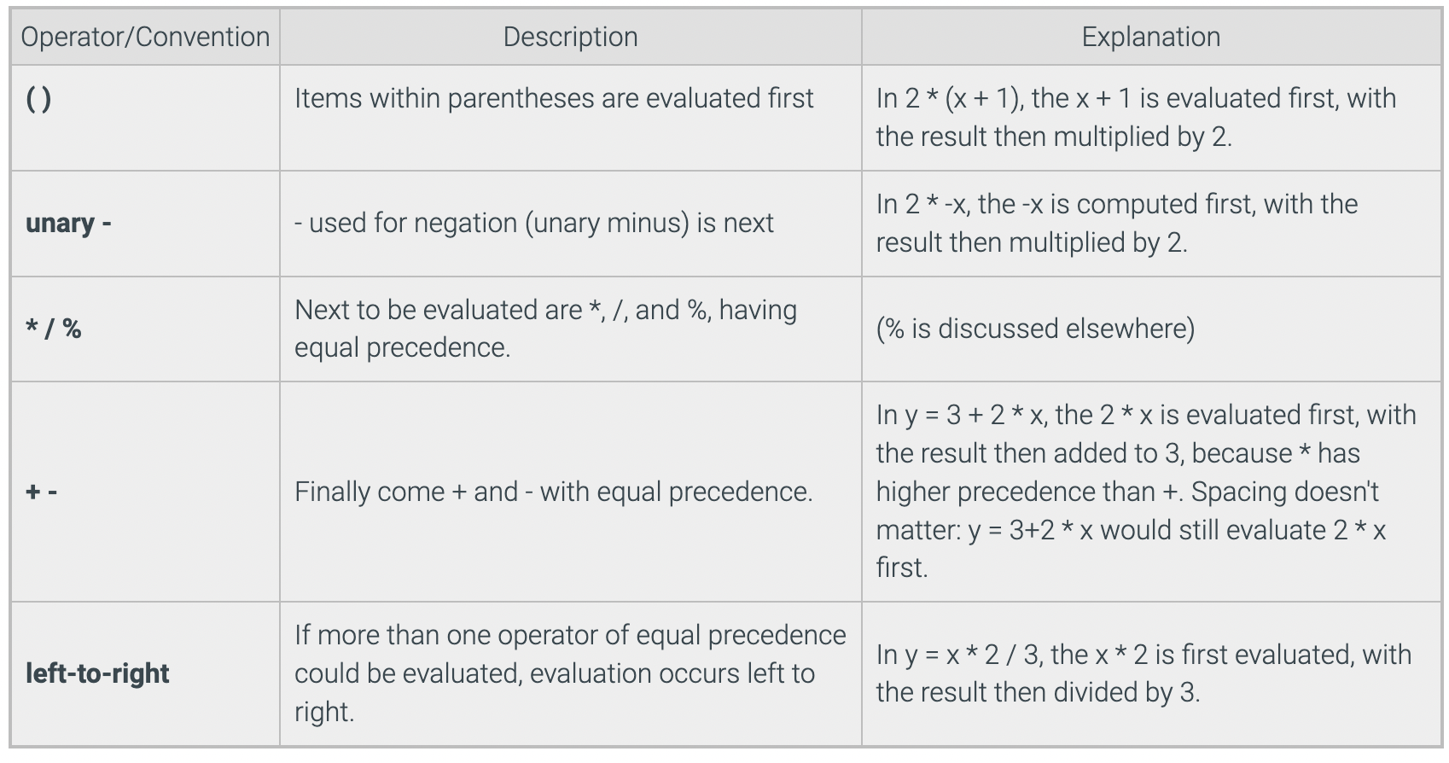

#include <cstring>;

**char** encodedMsg[ ] = "BAAANPALNEA"; for(int i = 0; i <strlen(encodedMsg); i++)

11 chars but array is 12 bc ‘\0’ (zero byte) strlen(encodedMsg) = 11

strcpy(destStr, sourceStr)

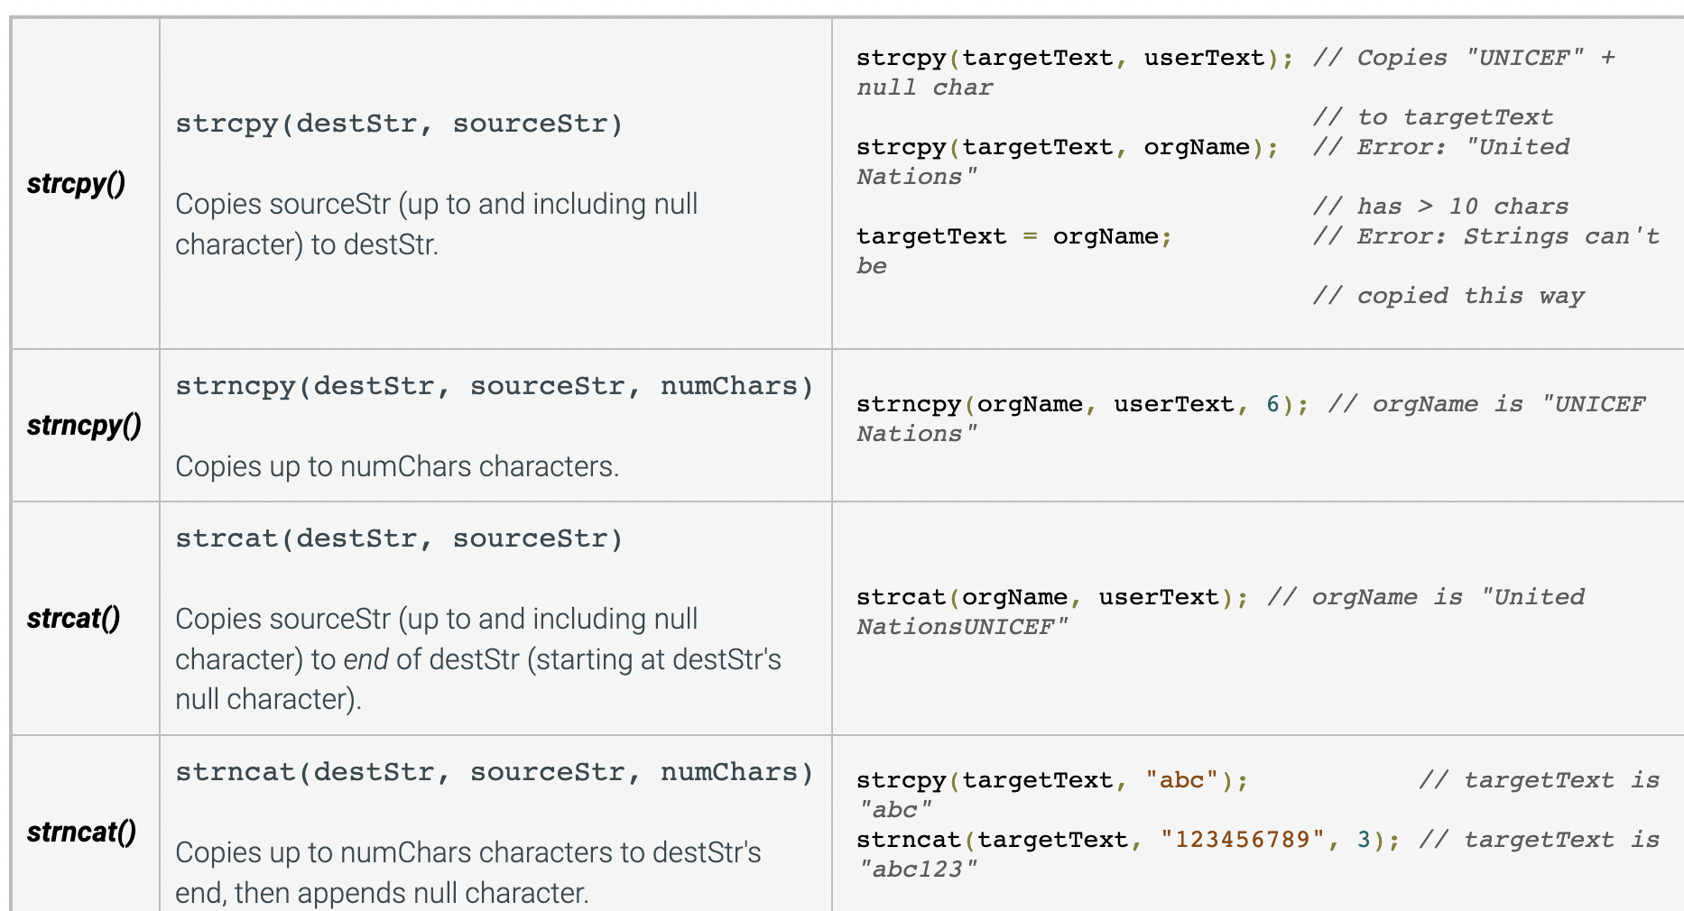

char orgName[100] = "United Nations";

char userText[20] = "UNICEF";

char targetText[10];

char orgName[100] = "United Nations"; char userText[20] = "UNICEF";

char targetText[10];

